Daily Diary App Design
Version 1.0
- Installation of the app utilizes a database helper class to establish a database as outlined in Data Structures, including default entries.  - When app is started, check Local Settings table.  If all settings except Consent have been recorded, skip this step and proceed to ask for PIN. (Consent is a checkbox so decline and no response are equivalent)  If settings have not been recorded, launch Settings  - Settings view consists of a linear layout to display setting descriptions and input fields  - Intent to launch Settings contains data (added via putExtra) that identifies view components to display. If none have been specified, default to display all, as the case is with the initial launch of the app.  - Populate fields on LoadFinished  Do not populate PIN and security questions if intent indicates displaying PIN and security questions only.  - Use password style text fields for PIN and security question responses  - Collect PIN twice and confirm match  - Format and length validation for Subject ID and Verification Code  - Data/time widgets to collect only valid date/time entries  - Checkbox for Tracking Consent  - Populate security questions spinner from lookup table; List different options for each of the two questions based on question group.  - Store entered settings in Local Settings table on Pause  - Save button confirms all input (except Consent) has been entered and leads to:  - Previous page if intent indicates hiding static settings (i.e. coming from Settings menu)  - PIN entry, otherwise; clear back stack in this case. | 1
- With the exception of initial setup, every activity:  - Implements a postDelayed Handler that opens the PIN view after the period of time based on settings has passed  - Opens the PIN view when app goes to background  The Start, Stop, BackPressed, and WindowFocusChanged events are utilized to track app background/foreground state  PIN view components:  - Input field requiring four-digit entry  - “Forgot PIN” launches Security Questions  - “Login with access code” reveals an input field for entering a six-digit access code and leads to reset process for PIN and security questions  - OK button compares submitted PIN to the one stored in Local Settings. If both match, launch Diary.  Launching PIN clears back stack so that PIN is the only accessible interface of the app. | 2
- Include counter in PIN activity for number of times PIN is submitted and launch Security Questions after three failed attempts. The counter is tied to the activity cycle so it will reset when activity is created but not when it is restarted.  Security Questions view components:  - Spinners for the two security questions  - Password style text fields accompanying each spinner  - “Forgot Responses” starts the reset request process  - OK button compares entered responses to stored Local Settings | 2.a
- If responses entered for both questions match what is in the database, launch Settings with intent to show PIN only. | 2.b
- Reset request process results in addition of a record, if one does not exist, to the Reset Request table on the server, and displaying an appropriate message as indicated below (in ovals):  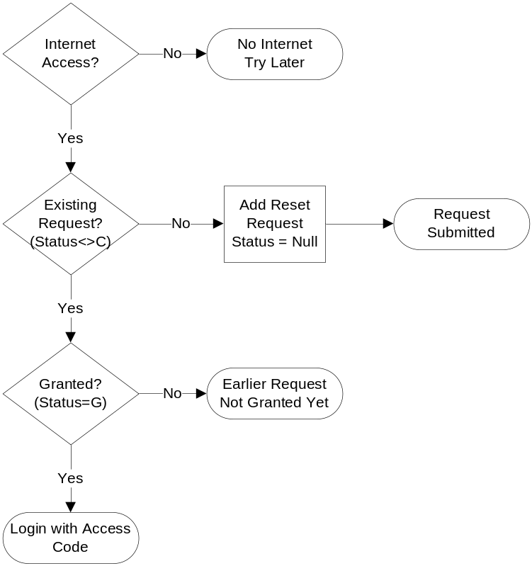 | 2.c
- Include counter in Security Question activity for number of times security responses are submitted.  - After two failed attempts, display suggestion to use “Forgot Responses” and indicate app will exit after the next failed attempt.  - Exit the app after three failed attempts.  If exiting the app is not feasible, consider unloading Security Questions to return to PIN. | 2.d
- Reset process for PIN and security questions collects new PIN and security questions if a reset request has been granted (Status=G). Requests are granted by the clinic in the online data entry system.  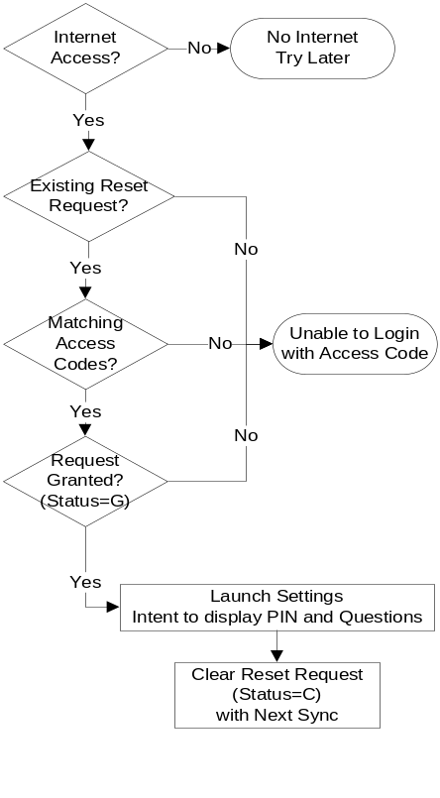 | 2.e  2.f
- Diary launch involves content exchange with the server via asynchronous tasks and identifying sections of the diary to display. | 3
- If Internet is accessible, launch asynchronous tasks to update local tables and synchronize pending data with the server. | 3.a
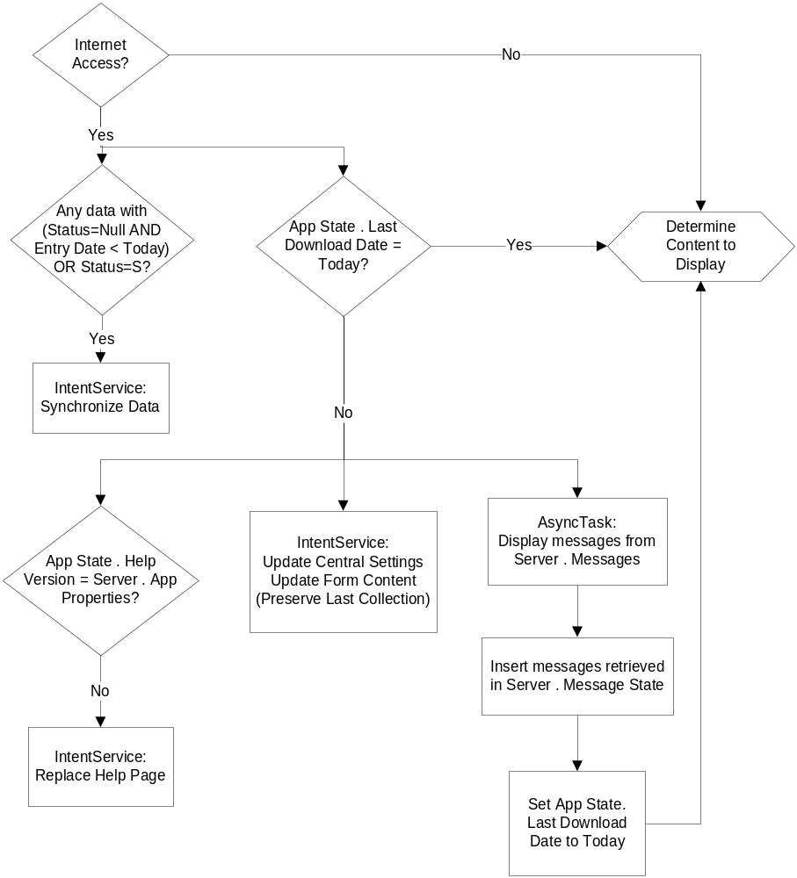 | 3.a.i  3.a.ii
- Display of the Diary elements is driven by the Form Content table.  - For any element with a matching ID in this table, use Frequency, Window and Last Collection Date to determine if the element should be visible or not.  - A Form Content record with no ID, if present, applies to all elements without a matching ID. | 3.b
- Sample Form Content configuration: | 3.b.i  3.b.ii  3.b.iii
  Form | ID | Label | Frequency (days) | Window Start | Window End | Time Category | Last Collection
  Diary | Null | Diary | 1 | 00:00 | 23:59 | AM
  Nitro | q_nitro | Nitrogen | 2 | 00:00 | 23:59 | AM
  Flow_AM | q_flow_am | AM Flow | 1 | 6:00 | 11:59 | AM
  Flow_PM | q_flow_pm | PM Flow | 1 | 18:00 | 23:59 | PM
- Data-bound elements, whether on the Diary view or any of its secondary views, are pre-populated on LoadFinished in two cases:  - A pending record exists: Status = Null AND Entry Date = Today  - Daily Diary Specifications require populating the field  In this case, retrieve the value to pre-populate with from Preset Values  If the first case is applicable, the second is ignored. | 3.b.iv
- If Form Content evaluation yields no Diary elements to present, Toast a message stating the next expectation based on Form Content.  - Refer to the Label field for the expectation message.  - Following the Toast, launch Intent to return Home without making any of the view elements visible. | 3.b.v
- Conversely, if there are elements to present, make the Submit button visible. | 3.b.vi
- Submit launches Intent to start a new diary activity thereby saving the data on Pause and resulting in evaluation of content to display.  - The record is initially saved with Status = S.  - Launch of the new diary detects this record and triggers Intent Service to synchronize data.  - When launching diary, clear back stack to remove the former diary.  - If saving the diary when Submit has not been clicked, leave Status Null. | 3.b.vi.1  3.b.vi.2
- A separate activity is launched for each section of the diary requiring a separate view.  - Secondary activities are associated with their own individual tables.  - A Return button leads to previous view in stack.  - The general save on Pause approach records all secondary data before return to diary.  - Secondary data is saved with Status = Null.  - Synchronization includes all secondary data as well as the main diary. | 4
- A button on the diary launches the Peak Flow activity. | 4.a
- Peak Flow consists of a number of numeric text fields, only the first of which is enabled. Each field is accompanied by a button to click when a flow value has been entered. | 4.a.i
- The button starts a Progress Dialog that opens the next field after a set period of time has passed. | 4.a.ii
- Medications implement a List-Entry (Master-Detail) pair of activities.  - The List is launched when user response indicates medications were taken.  - A negative response results in deleting any existing medication records in Medications table where Status is not Q.  - Medications with Status other than Q are listed on the diary. | 4.b  4.b.ii.1
- List components:  - A grid based on Preset Lists for the Medication list with each row containing:  - Medication Name  - Dosage  - Frequency  - Whether medication was taken (yes/no)  - Button to edit row; launches Entry holding row values  The only field accepting input here is whether medication was taken, which is not in itself a data-bound field. All others are displayed text.  - Button to add medication; launches blank Entry  - Return button; for any row of the grid where medication is indicated to have been taken, adds a record to Medications based on Name, Dosage, and Frequency from Preset Lists. Returns back to diary. | 4.b.i  4.b.ii  4.b.iv
- Entry components:  - Input fields for:  - Medication Name  Uses Auto Complete Text View based on Auto Complete table.  - Dosage  Auto complete but using only dosages matching the entered medication.  - Frequency  - Return button adds/updates Preset List record and returns to the List.  - Button to delete entry deletes the Preset List record and returns to the List. | 4.b.iii  4.b.iv  4.b.iv.1  4.b.iv.2
- A button on the diary launches the Nitrogen activity which is collected in a single numeric field. | 4.c
- Supplements function similar to medications. | 4.d
- Subclass IntentService to create a synchronization class that posts the following content as JSON to a web service:  - Diary including all secondary activities.  Change Status to Q and record Last Collection in Form Content  - Location tracking data from Location Info.  - Settings from Local Settings.  Posted diary and tracking data will be inserted in the study database by the service while settings will be initially inserted, then updated as necessary. | 5  5.a  5.b  5.c
- The service will change the status of any existing reset requests to C. | 5.d
- Include Verification Code and Patid in the post for the service to verify. | 5.e
- After executing the post, clear the data tables. | 5.f
- Must work this out with MokiManage | 6
- Define options menu resources, including language code extensions: | 7
- Settings issues intent to launch Setting with static settings invisible | 7.a
- Help launches an implicit intent to display the help page in a browser | 7.b
- When updating central settings during diary launch, register tracking alarms with Alarm Manager based on Tracking Start and Stop dates.  - Implement a corresponding Broadcast Receiver that registers a Location Listener with the Location Manager to obtain periodic location coordinates.  - When registering the listener, make sure services that provide location are active. If not, display dialog that leads user to device settings.  - The alarm to stop tracking stops the listener.  - Use fine location but remove decimal places from the captured data to have accuracy at 100 m.  - Since alarms are not retained after reboot, reschedule using a Broadcast Receiver set to receive BOOT_COMPLETED. | 8
- Store location as longitude and latitude in Location Info, precise to 3 decimal places, along with timestamp. | 8.a
- Send a notification to Notification Manager with a tracking icon to display while location tracking is on.  - Use a designated ID for removal of the notification when listener is stopped.  - Aside from stating that tracking is on, the notification does not need to invoke an activity. | 8.b
- Display a dialog stating changes in tracking state. When activating tracking, if Consent has not been given, present option to change and launch Settings with intent to display Tracking Consent only. | 9.c
- Reminders are similarly scheduled using Alarm Manager and Broadcast Receiver for launching associated activities. | 9
- Set repeating alarms for data collection using Frequency, Last Collection, Time Category, and Label from Form Content and Notification Times in Local Settings.  Display dialog only if collection form is not currently active and data has not already been collected. | 9.a
- Set a daily alarm at Morning Notification Time that results in displaying a dialog if Last Collection Date + Data Lapse = Today | 9.b
- Extend resources with language code and define strings for each language in a separate strings.xml | 10

Device Tables
Security Questions
Question ID
Question Group
Question Text
Form Content
Form Name
Element ID (Null = All elements on form)
Label
Frequency
Window Start
Window End
Time Category
Last Collection Date
Local Settings
Patid
Verification Code
Issue Date/time
Security PIN
Security Question 1 ID
Security Question 1 Response
Security Question 2 ID
Security Question 2 Response
Morning Notification Time
Evening Notificatoin Time
Tracking Consent
Central Settings
Tracking Start Date
Tracking Stop Date
Inactivity Lapse (has default)
Data Lapse (has default)
App State
Last Download Date
Help Version (has default)
Preset Values
Form Name
Element ID
Preset Value
Preset Lists
List Name
Item Sequence
Item Name
Dosage
Frequency
Location Info
Date
Time
Latitude
Longitude
Medications
Medication Name
Dosage
Frequency
Status
Auto Complete
List Name
Item Name
Dosage
Supplements
Supplement Name
Dosage
Frequency
Status
Diary
…
Status
Peak Flow AM
…
Status
Peak Flow PM
…
Status
Nitrogen
…
Status
HTML Help Page (has default; stored as a file, not necessarily in database)
Server Tables
Reset Request
Site
Prot
Projid
Status
Reset Code
[Admin. Fields]
Messages
Patid (Null = All Participants)
Message ID
Subject
Message
Date Posted
Expiration Date
Message State
Patid
Message ID
Status (For now only status is D=Delivered)
App Properties
Help Version
Central Settings
Patid
Tracking Start Date
Tracking Stop Date
Inactivity Lapse
Data Lapse
Subject Settings
Patid
Verification Code
Issue Date/time
Security PIN
Security Question 1 ID
Security Question 1 Response
Security Question 2 ID
Security Question 2 Response
Morning Notification Time
Evening Notificatoin Time
Tracking Consent
HTML Help Page (Stored as a file; not necessarily in database)

